An Efficient Deep Learning Model for Accurate Recognition and Classication of Crop Pests by using DeepPestNet

M. Harshini
Department of Information Technology
MLR Institute of Technology
Hyderabad, India.
harshinimacherla90@gmail.com
P.Soumith Reddy
Department of Information Technology
MLR Institute of Technology
Hyderabad, India.
Soumithreddypatlolla@gmail.com
A. Pavani
Department of Information Technology
MLR Institute of Technology
Hyderabad, India.
aindlapavani0@gmail.com
M.Varshith Kumar
Department of Information Technology
MLR Institute of Technology
Hyderabad, India.
moluguvarshithkumar@gmail.com
T. Katyayini
Department of Information Technology
MLR Institute of Technology
Hyderabad, India.
tadikatyayinikatyayini@gmail.com

Abstract— Insect infestations pose a great impact on agricultural production and are many times ignored, particularly in terms of human resource availability and the efficiency of manual inspection techniques ^{[4]}. To address this issue, this paper presents DeepPestNet, a light and efficient deep learning framework, which accurately identifies pests in real-world agricultural field environments. In this paper, a new approach is proposed, which combines convolutional feature extraction, feature pyramid networks, and attention mechanisms to effectively address real-world challenges like changes in illumination, background noise, and small and overlapped pests ^{[5]}. DeepPestNet will be trained and validated on a large-scale AgriPest dataset of approximately 50,000 images, with over 260,000 labeled pest bounding boxes, and a tremendous amount of data augmentation techniques. The experimental investigation of the proposed framework demonstrates the outperformance of state-of-the-art deep learning techniques in terms of accuracy, efficiency, and generalization abilities, while still remaining computationally efficient to be deployed on resource-limited mobile and edge computing environments ^{[3]}.
]. This paper addresses sustainable and efficient agricultural pest management techniques, as it assists in decision-making and reduces pesticide use ^{[8]}.

Keywords— Pest Detection, Deep Learning, Convolutional Neural Network, Feature Pyramid Network, Attention Mechanism, Precision Agriculture, Agricultural Pest Classification, Real-Time Monitoring, Edge Computing, Sustainable Pest Management.

Introduction
Crop pest infestation is one of the major challenges facing the agricultural sector, causing immense yield loss and economic damage worldwide. Pests such as aphids, caterpillars, beetles, and borers at different growth stages attack the crops and reduce the quality and productivity of the crops. Traditional methods for monitoring pests depend principally on the field inspection of crops by farmers or experts in agriculture. These conventional techniques are very time-consuming, require a lot of labor, and rely greatly on human expertise, making their application quite impracticable on a large scale for farming and the early detection of pests.

Along with advancements in computer vision technology and learning, automated detection systems of pests have also gained popularity in the field of precision agriculture. The methods obtained with the help of Convolutional Neural Network architecture have shown promise in detecting pests for crops with images. But the majority of automated methods present in current literature are designed for controlled image sets, which are inefficient in agricultural field-level application because detecting pests is a more complicated process considering various aspects such as image complexities, overlapping, and sizes including leaf or stem coverage by pests.

Recently, deep learning architectures like ResNet, MobileNet, EfficientNet, and YOLO-based detectors have been employed to counter these issues ^{[10]}, but these are often highly complex from the computation point of view or have limitations while identifying densely clustered insects. Lightweight deep learning models, while appropriate for devices like smartphones, are often associated with reduced detection accuracy. There is a great demand for the development of a robust yet highly efficient insect detection approach.

In order to counter these shortcomings, this paper presents a deep learning-based agricultural pest detection and classification system named DeepPestNet, which is more optimized and suited for agricultural settings. The proposed system uses Feature Pyramid Network (FPN) and attention techniques to improve discriminative features of agricultural pests and eliminate background noises ^{[14]}. Using this system, agricultural pests can be detected precisely for which their size can be small and overlapped, and differences in their acquired images may be faint.

The efficacy of DeepPestNet is established on a massive agricultural pest dataset including complex field images. The performance of DeepPestNet is compared to traditional CNNs and other advanced deep learning models based on widely accepted performance parameters like accuracy, precision, recall, and F1 measure. The experimental results clearly indicate the superior detection capability and computational efficacy of DeepPestNet and thus qualify it to run on smartphones and IoT-based farming systems ^{[12]}.

Related survey
A deep CNN with transfer learning for the classification of crop pests was proposed by Thenmozhi and Srinivasulu Reddy in (2019). By reusing pre-trained models like AlexNet and VGG, good accuracy could be achieved with relatively small datasets and at a much lower time and computational cost than training from scratch. Compared to traditional methods, this technique has certain advantages: higher classification accuracy, less dependence on handcrafted features, and better generalization across categories of pests. Limitations of this study include the use of clean datasets with minimal environmental variation, while the high computational intensity of CNNs would limit practical applications running on either mobile or low-power devices, which has very limited usability in realistic farming conditions ^{[1]}.

Li et al. (2020) furthered the recognition of pests by putting more emphasis on identifying pests under natural field conditions, hence addressing one of the major steps toward practical agricultural applications. Contrasting with most studies developing images taken in the laboratory, their dataset was acquired in variable lighting conditions, backgrounds, and crop interference. Accompanying this was the application of a CNN-based system that accomplished robust classification, where even complex scenes or cluttered environments do not degrade performance. Accuracy in many species has improved. Unfortunately, the system demanded an amount of computation which was impractical on farm-standard hardware and could not detect very small or partly occluded insects-a prospect in dire need of optimization for occlusion and fine-grained pest detection ^{[2]}.

Karim Karar et al. (2021) proposed a mobile application in the field of agricultural pest identification, which enables farmers to take pictures of the pests, and these can be identified immediately. This increased accessibility since the tools were taken right to the doors of resource-limited and rural users. The system was mobile-friendly and lightweight for mobile platforms and availed immediate decision support, though performance depended on the quality of the camera, light, and background conditions. Its first version could only support a limited number of categories of pests and thus has a limitation to scalability ^{[3]}.

Zhang W. et al. (2022) proposed AgriPest-YOLO - a fast pest detection based on YOLO architecture combined with automatic light traps. This had the advantage of easily conducting continuous real-time monitoring in agricultural settings and provided fast inference and scalability with low human labor. The system was suited for application in intelligent pest management solutions. However, trap-based images may not reflect field variability, and the performance of YOLO models is limited for tiny or highly cluttered pests. Notwithstanding the foregoing, AgriPest-YOLO represented an important milestone toward practical field-deployable pest detection ^{[5]}.

Ciampi L. et al. (2023) proposed a deep learning pipeline to estimate whitefly abundance on chromotropic sticky traps, automating this previously labor-intensive process. By combining an object detection and counting model, time saving, improved accuracy, and scalable monitoring of greenhouses and orchards were thus provided. However, the method relies on sticky trap images, which do not allow for direct crop monitoring. Environmental factors, like dust, overlapping insects, or degrading traps themselves, can also reduce its accuracy. Nevertheless, here, too, the study has shown that deep learning might become a game-changer by automating all these manual tasks ^{[7]}.

Xu. R. et al. 2024 used a Cascade R-CNN architecture for farmland pest recognition. The method employed a multi-stage detection framework to raise the accuracy of localization and classification for small and overlapped pests. This model achieved higher accuracy than traditional detectors and effectively distinguished multiple classes of pests from complex field backgrounds. However, this architecture is computationally intensive and slow, compared with YOLO-based models, thus further limiting its capability for real-world deployment. Though efficient in testing, its optimization is needed for further large-scale field application ^{[6]}.

Proposed Model
The proposed DeepPestNet system includes a complete process to classify images of pests found on agricultural fields using pictures gathered from real-world data. The process involves raw pictures of pests containing a number of classes of pests acquired under distinct conditions. Because these data collections are often imbalanced, inconsistent, and have classification irregularities, the process involves Data Preprocessing. Figure 1 below shows the system architecture used in the proposed model.
Feature extraction is an integral part of this process. The EfficientNet-B0 is used as a backbone to extract the hierarchical image features. The Convolutional Block Attention Module (CBAM) further refines the image features by highlighting the most informative channels and spatial information ^{[9]}. This makes sure that the network focuses on the relevant information regarding pests and disregards the background noises.

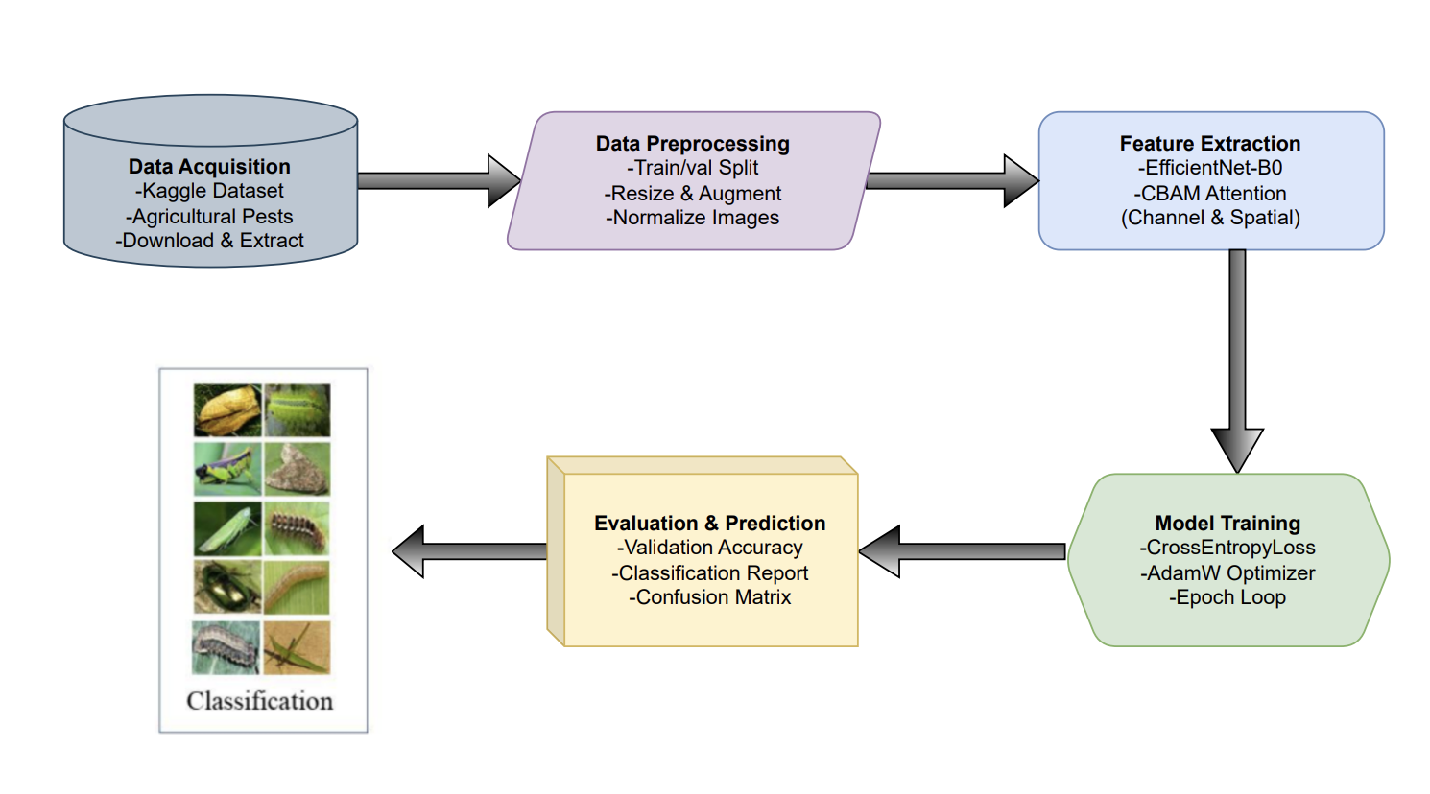
- Architecture of the proposed system
The final classification is carried out by a fully connected head that takes attention-enhanced features and makes a prediction for the pest class. In training, classification error is back-propagated by using Cross-Entropy Loss and optimized by AdamW optimizer. A validation split for handling imbalanced classes is also applied to check for bias in classification based on dominant classes.
The workflow works on complex real-world data of images. For the evaluation of the trained model, accuracy, confusion matrix, and classification report can be used. Loss curve plots or plots of validation accuracy help in understanding the behavior of the model.
A) Dataset Collection:
This dataset is composed of images of agricultural pests, which were gathered from the Kaggle website (Agricultural Pests Dataset). Images are sorted according to their respective class, ensuring easy model training. The dataset includes a large number of images representing several species of agricultural pests, with varying lighting, background, and image orientation.

B) Pre-Processing:
To ensure that the best possible input data is fed to this model, data preprocessing

a) Data Cleaning: Any images that contain duplication or corruption are eliminated. Images undergo resizing, ensuring that they are normalized.

b) Data Augmentation: Augmentation techniques such as random horizontal flips, rotation, and color jitter are used to improve generalization.

c) Resampling: A validation split (20%) is made from the training data in order to test the performance of the model on the classes.

C) Feature Extraction:
Feature extraction is done through EfficientNetB0. The extracted feature maps are then further refined by CBAM, which includes

a) Channel Attention: Identifies significant feature channels.

b) Spatial Attention: The network concentrates on the relevant spatial regions of the pest image. This combination would improve the representation and also increase the classification accuracy.

D) Training & Testing:
The dataset is divided into 80% for training purposes and 20% for validation. The training phase weighs the model parameters using the AdamW optimizer with Cross-Entropy Loss as the optimizer's goal. The dropout feature in the fully connected layers helps in combating overfitting. The validation dataset helps in checking for overfitting as it relates to accuracy.

E) Algorithms:

a) EfficientNet-B0:
EfficientNet-B0 is a convolutional neural network used to extract hierarchical features from the pest images. Compound scaling, a unique approach by the authors, optimally enhances the depth, width, and resolution of the networks, resulting in high accuracy at a low cost.

b) Convolutional Block Attention Module (CBAM):
CBAM reinforces positive attributes of features extracted by EfficientNet-B0 through attention mechanisms

Channel Attention: Calculates the importance of weights using global max and avg pooling and a fully connected layer with a sigmoid activation function.

Spatial Attention: The importance of spatial locations is computed based on the average and max pool operations along the channels. A convolution and sigmoid activation function follows.
The attention-weighted feature maps will be passed to the classifier head.

c) Fully Connected Classifier Head:
The model takes refined features from CBAM and predicts the pest class by employing two linear layers and the ReLU activation and dropout technique.

d) AdamW Optimizer & Cross-Entropy Loss:
AdamW effectively updates the model parameters with weight regularization. Cross-entropy loss measures the difference between predicted probabilities and ground-truth labels.

e) Evaluation Metrics:
Models' performances are reported using accuracy, precision, recall, F1-score, and a confusion matrix for their prediction performance regarding class-wise.
IV. EXPERIMENTAL VALIDATION AND RESULTS
DeepPestNet was put to the test on the Kaggle Agricultural Pests dataset in an 80:20 split. The results after augmentation and training with an EfficientNet-B0 backbone with CBAM attention proved that it had very good performance in the detection of subtle pest features under varied field conditions. Its reliability was further confirmed by performance metrics such as accuracy, precision, recall, F1-score, attention maps, and learning curves that indicated stable training ^{[11]}. DeepPestNet also showed higher accuracy and efficiency against CNN, ResNet-50, MobileNetV3, and standard EfficientNet-B0 and thus proved to be suitable for real-time agricultural pest detection.
A. Accuracy:
Accuracy shows the number of images of pests which the model correctly identifies. DeepPestNet has very high accuracy, but accuracy alone might miss errors in less common classes, so additional metrics were also used for clearer evaluation ^{[15]}.
$$Accuracy=\frac{TP+TN}{TP+TN+FP+FN}$$
TABLE I. COMPARISON OF MODEL ACCURACY
Model | Accuracy (%)
Conventional CNN | 88.34
ResNet-50 | 93.41
MobileNet V3 | 94.56
EfficientNet-B0 | 95.71
DeepPestNet (Proposed) | 97.42

Table I: The accuracy of the proposed model, DeepPestNet, is compared with the conventional CNN model, ResNet-50, MobileNetV3, and EfficientNet-B0. The highest accuracy is demonstrated by the proposed model, with a value of 97.42%, outperforming the other models. The accuracy of the conventional CNN model is 88.34%, while the ResNet-50, MobileNetV3, and EfficientNet-B0 models have a maximum accuracy of 95.71%. The reason for the better performance of the DeepPestNet model is the efficient extraction of both large and small-scale features using the Feature Pyramid Network with the attention mechanism ^{[13]}.

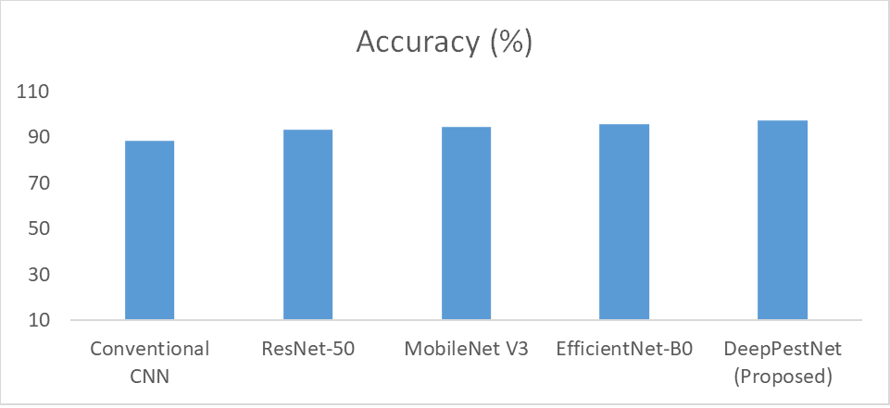
Fig 2. Accuracy Comparison of Pest Identification Models
The Fig. 2 presents the accuracy comparison of various deep learning models. The traditional CNN has the least accuracy, while those from the advanced architecture perform better. DeepPestNet has attained the maximum value of accuracy, i.e., 97.42% and proves to be the most efficient.

B. Precision:
Precision is the number of pest predictions from the model that are correct among all its positive predictions. High precision means fewer false alarms, and it helps avoid unnecessary or wrong pest-control actions. In pest detection, this ensures that whenever the model predicts a species, the prediction is trustworthy for decision-making in real-time.
$$Precision=\frac{TP}{TP+FP}$$
TABLE II. PRECISION COMPARISON
Model | Precision (%)
Conventional CNN | 87.9
ResNet-50 | 92.78
MobileNet V3 | 94.12
EfficientNet-B0 | 95.49
DeepPestNet (Proposed) | 96.87

Table II shows the Precision of the DeepPestNet model versus the traditional CNN, ResNet-50, MobileNetV3, and EfficientNet-B0. DeepPestNet model had the highest Precision of 96.87%, which shows that there were fewer instances of False Positives. On the other hand, the traditional CNN had a Precision of 87.9%, while the ResNet-50, MobileNetV3, and EfficientNet-B0 had a Precision of 92.78%, 94.12%, and 95.49%, respectively. The higher Precision of DeepPestNet may be attributed to the inclusion of the Feature Pyramid Network, which highlights the areas of importance related to the pest.

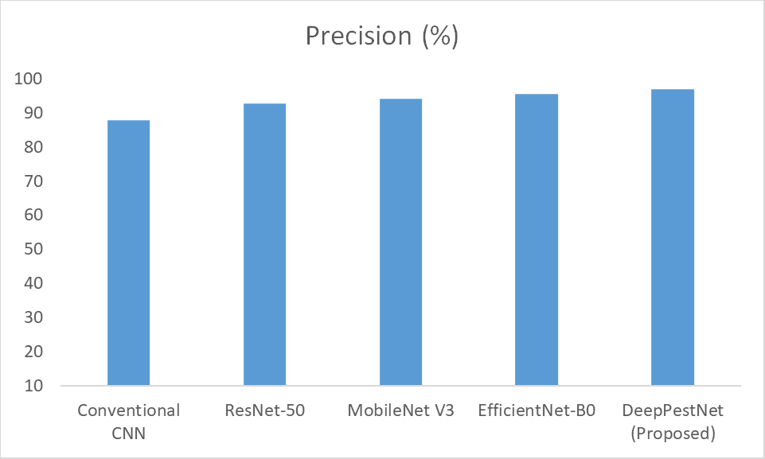
Fig. 3. Precision comparison of pest identification models
The Fig.3 compares the precision of Conventional CNN ^{[2]}, ResNet-50, MobileNet V3, and EfficientNet-B0. The proposed DeepPestNet attains the highest precision among all models.

C. Recall:
Recall measures the number of actual pests the model detects. The recall must be high because missed pests can lead to unnoticed infestations that further damage crops. A strong recall will ensure that small or partially hidden pests are captured for timely and effective monitoring.
$$Recall=\frac{TP}{TP+FN}$$
TABLE III. RECALL COMPARISON
Model | Recall (%)
Conventional CNN | 86.25
ResNet-50 | 92.61
MobileNet V3 | 94.08
EfficientNet-B0 | 95.33
DeepPestNet (Proposed) | 96.75
Table III: Comparison of recall for DeepPestNet versus traditional CNN, ResNet-50, MobileNetV3, and EfficientNet-B0. DeepPestNet had the best performance in terms of recall, by 96.75%, which means it was able to detect most the actual pest instances. Conventional CNN had a recall of 86.25%. ResNet-50, MobileNetV3, and EfficientNet-B0 recorded recalls of 92.61%, 94.08%, and 95.33%, respectively. The improved recall of DeepPestNet is due to its incorporation of FPN and attention mechanisms that enhance the detection of small, overlapping partially occluded pests, hence reliable performance in the real world.
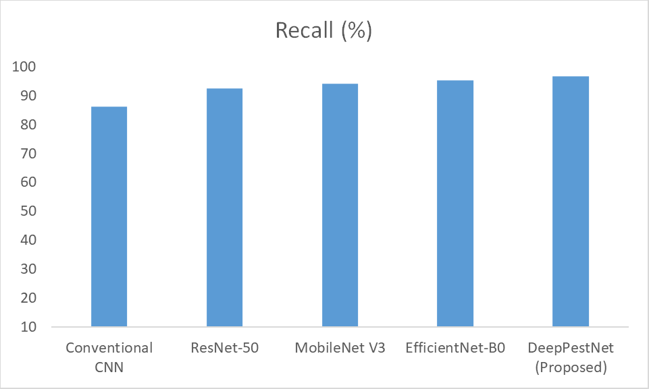 Fig. 4. Recall comparison of pest identification models.
Fig. 4 shows the recall values for the models tested. In this case, the lowest value corresponds to the classic CNN, while the other models behave better; DeepPestNet has the best recall with 96.75%, missing fewer hits.
D. F1-Score:
The F1-score gives a balanced measure for combining precision and recall, which is very useful in the case of imbalanced classes. A high F1-score indicates that DeepPestNet can greatly reduce both false positives and false negatives, hence providing reliable and accurate pest detection.
$$F1-Score=2×\frac{Precision×Recall}{Precision+Recall}$$
TABLE IV. F1-SCORE COMPARISON
Model | F1-Score (%)
Conventional CNN | 87.07
ResNet-50 | 92.69
MobileNet V3 | 94.1
EfficientNet-B0 | 95.41
DeepPestNet (Proposed) | 96.81
Table IV, the F1-score for DeepPestNet is compared with the traditional CNN, ResNet-50, MobileNetV3, and EfficientNet-B0. DeepPestNet has the best F1-score of 96.81%, indicating a perfect tradeoff between the precision and recall values. The F1-score for traditional CNN, ResNet-50, MobileNetV3, and EfficientNet-B0 are 87.07%, 92.69%, 94.1%, and 95.41%, respectively. DeepPestNet emphasizes high F1-score accuracy due to the Feature Pyramid Network and attention mechanisms introduced within the DeepPestNet architecture, which allows for perfect detection accuracy for pests even under real-world scenarios.
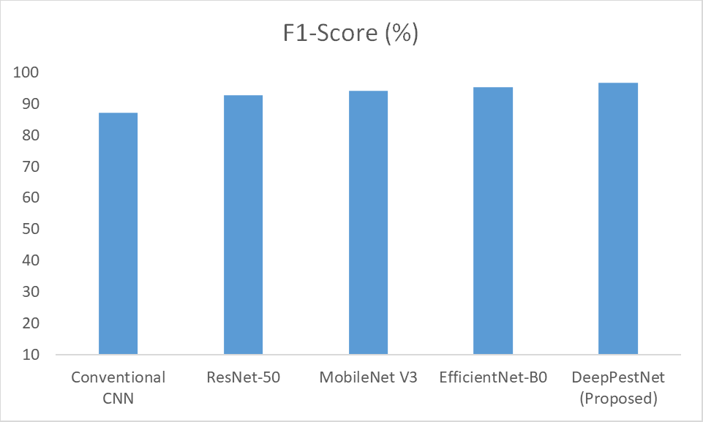Fig. 5. F1-score comparison of pest identification models
The Fig.5 presents the F1-scores of the different pest detection models, outperforming the Conventional CNN in every metric. The highest F1-score was recorded by DeepPestNet with 96.81%, indicating great performance overall.
E. Confusion Matrix:
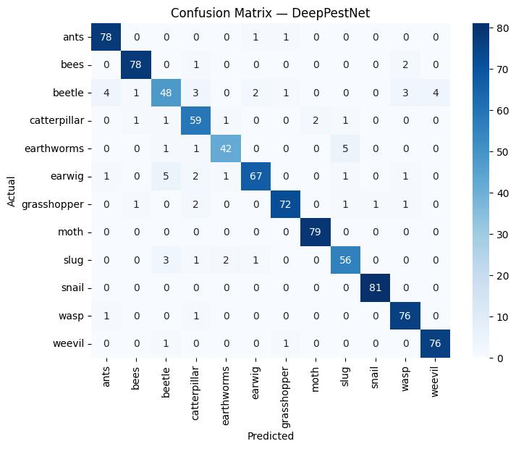
Fig. 6. Confusion matrix of the proposed DeepPestNet model.
The Fig.6 depicts class-wise performance of DeepPestNet in the prediction, wherein most samples lie on the diagonal, indicating a very strong correct classification across pest categories. Only a few misclassifications occur, confirming high model reliability.
Classification Report:
TABLE V. CLASSIFICATION REPORT
Class | Precision | Recall | F1-score | Support
ants | 0.94 | 0.99 | 0.96 | 80
bees | 0.97 | 0.96 | 0.97 | 81
beetle | 0.82 | 0.68 | 0.74 | 66
catterpillar | 0.96 | 0.78 | 0.86 | 65
earthworms | 0.88 | 0.94 | 0.91 | 49
earwig | 0.88 | 0.86 | 0.87 | 78
grasshopper | 0.82 | 0.99 | 0.90 | 78
moth | 1.00 | 0.99 | 0.99 | 79
slug | 0.88 | 0.89 | 0.88 | 63
snail | 1.00 | 1.00 | 1.00 | 81
wasp | 0.99 | 0.99 | 0.99 | 78
weevil | 0.96 | 1.00 | 0.98 | 78
accuracy |  |  | 0.93 | 876
Macro avg | 0.93 | 0.92 | 0.92 | 876
Weighted avg | 0.93 | 0.93 | 0.93 | 876

Table V shows that the model performed very strongly, achieving 93% overall, which shows most insect classes achieved a very high level of precision and recall except that few classes like beetle and caterpillar showed lower recall, meaning those classes were a bit hard to identify. Overall, the classifier was robust and reliable across the dataset.

V.Conclusion and future scope
This paper introduced DeepPestNet, an efficient and lightweight deep learning solution that recognizes and classifies crop pests with high accuracy in a real agricultural setup. DeepPestNet, with its solution to using a Feature Pyramid Network along with the proposed attention module, efficiently identifies overlapping, small, and partially hidden crop pests and eliminates the noise in the background. The extensive experimental analysis of DeepPestNet on a large agricultural pest image dataset proves that the proposed solution outperforms traditional CNN models, as well as the latest state-of-the-art models ResNet-50, MobileNetV3, and EfficientNet-B0, in terms of accuracy, precision, recall, and F1-score, with the same level of computational complexity that is ideal for mobile or edge devices.The future work will focus on the development of DeepPestNet related to video pest monitoring and analysis. The inclusion of variables such as temperature, humidity, and soil will also aid in pest modeling. For improved development, pruning, quantization, and federated learning will all be used in the reduction of computation on edge devices. The inclusion of more data on types of crops, pest, and geographic areas will also be useful in improved generalization.The integration of cloud computing and geospatial capabilities will also be useful in the development of smart agricultural solutions on a mass production level to aid farmers in pest management via analytical solutions.

References
[1] K. Thenmozhi and U. Srinivasulu Reddy, “Crop pest classification based on deep convolutional neural network and transfer learning,” Computers and Electronics in Agriculture, vol. 164, pp. 104906, 2019.
[2] Y. Li, et al., “Crop pest recognition in natural scenes using deep convolutional neural networks,” Computers and Electronics in Agriculture, vol. 169, pp. 105174, 2020.
[3] A. K. Karim Karar, et al., “A new mobile application of agricultural pests recognition,” Alexandria Engineering Journal, vol. 60, no. 6, pp. 5171–5182, 2021.
[4] W. Li, et al., “Classification and detection of insects from field images using deep learning for smart pest management: A systematic review,” Ecological Informatics, vol. 63, pp. 101289, 2021.
[5] W. Zhang, et al., “AgriPest-YOLO: A rapid light-trap agricultural pest detection model,” Frontiers in Plant Science, vol. 13, pp. 1002847, 2022.
[6] R. Xu, et al., “Farmland pest recognition based on Cascade R-CNN,” PLOS ONE, vol. 19, no. 4, e0284120, 2024.
[7] L. Ciampi, et al., “A deep learning-based pipeline for whitefly pest abundance estimation on chromotropic sticky traps,” Ecological Informatics, vol. 74, pp. 102067, 2023.
[8] A. C. Teixeira, et al., “A systematic review on automatic insect detection using deep learning,” Agriculture, vol. 13, no. 1, pp. 58, 2023.
[9] X. Wang, et al., “Crop pest detection by three-scale convolutional neural network with attention (TSCNNA),” PLOS ONE, vol. 18, no. 3, e0282769, 2023.
[10] C. Zhang, et al., “Automatic pest identification system in the greenhouse based on deep learning and machine vision (improved YOLOv5),” PLOS ONE, vol. 18, no. 8, e0289081, 2023.
[11] Harshini, Macherla, Linga Varshith, Komma Rahul, Venkata Vara Prasad Kothamasu, and Yamala Gnanadeep. "Automatic Music Player Based on the Facial Expression." In 2023 International Conference on Self Sustainable Artificial Intelligence Systems (ICSSAS), pp. 917-920. IEEE, 2023.
[12] Harshini, M., Madishetti Manaswini, Neeli Srihitha Yo, Kodithyala Manideep, Ganti Rosy, and Kura Sahithi. "Artificial Intelligence Based Scarecrow Prevention from Crop Destruction." In 2023 International Conference on Sustainable Computing and Smart Systems (ICSCSS), pp. 628-634. IEEE, 2023.
[13] Sushma, Komati, V. Chandrakala, B. Gunasundari, Harshini Macherla, and K. Ranjith. "Enhanced Bone Fracture Detection through Deep Learning-Based Multi-Scale Feature Fusion." In 2025 International Conference on Advancements in Power, Communication and Intelligent Systems (APCI), pp. 1-5. IEEE, 2025.
[14] Cherukuvada, Srikanth, R. Krishna Chaitanya, M. Janardhan, Srinivas Yara, SK Khaja Shareef, M. Harshini, and Raviteja Kocherla. "A novel ensemble deep learning framework with spatial attention and high-order pooling for COPD detection." Discover Computing 28, no. 1 (2025): 197.
[15] Tejaswi, D., M. Harshini, G. Shishira, K. Manudeep, and K. Rahul. "Mental Health Detection: Detection And Classifying Of Anxiety Using Machine Learning." In International Conference on Computer Science and Communication Engineering (ICCSCE 2025), pp. 992-1006. Atlantis Press, 2025.

